**Assignment No : 3**

**Title – Feedback and Constraints (Individual)**

**Feedbacks - Madhav Jadhav**

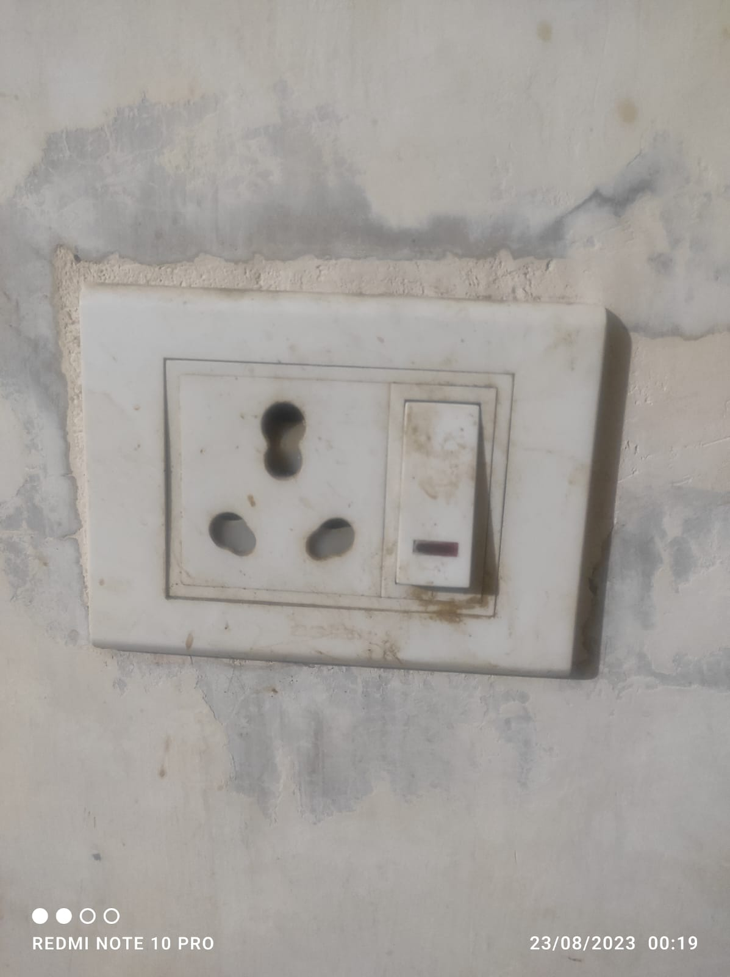

**Source –** My House (Kitchen)

**Feedback –** When the switch is turned on the Red light on the switch is also turned on indicating that the power is flowing properly and also indicates that the switch is also turned on.

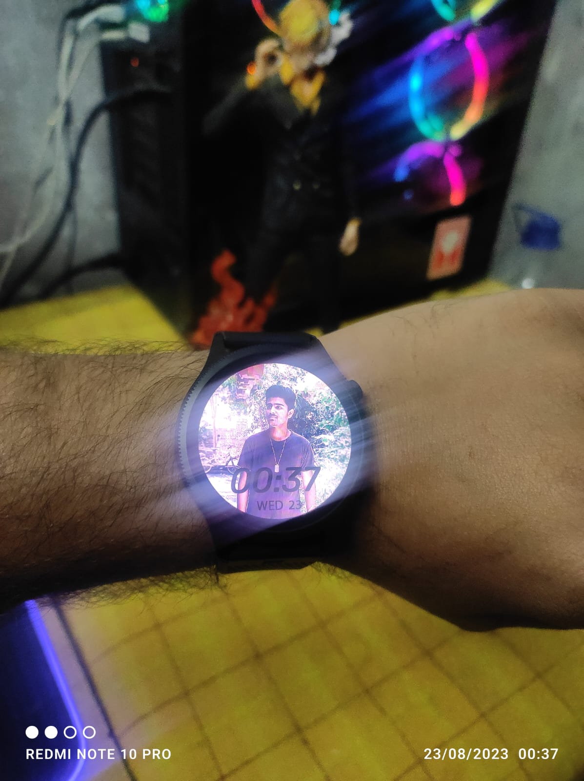

**Source –** My House (My Hand)

**Feedback –** When we perform the wrist rotation gesture at that time the watch face turn on to show time.

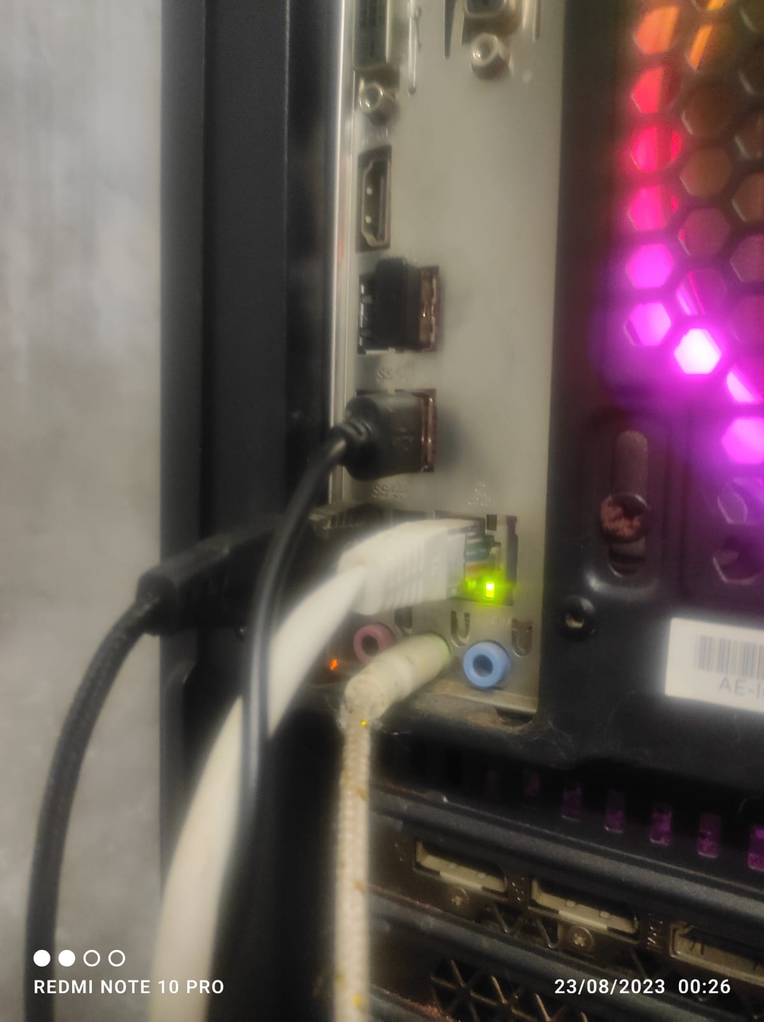

**Source –** My Room

**Feedback –** when the RJ45 is inserted in the ethernet port at that time the port lights up to indicate that the RJ45 is connected properly.

**Constraints - Madhav Jadhav**

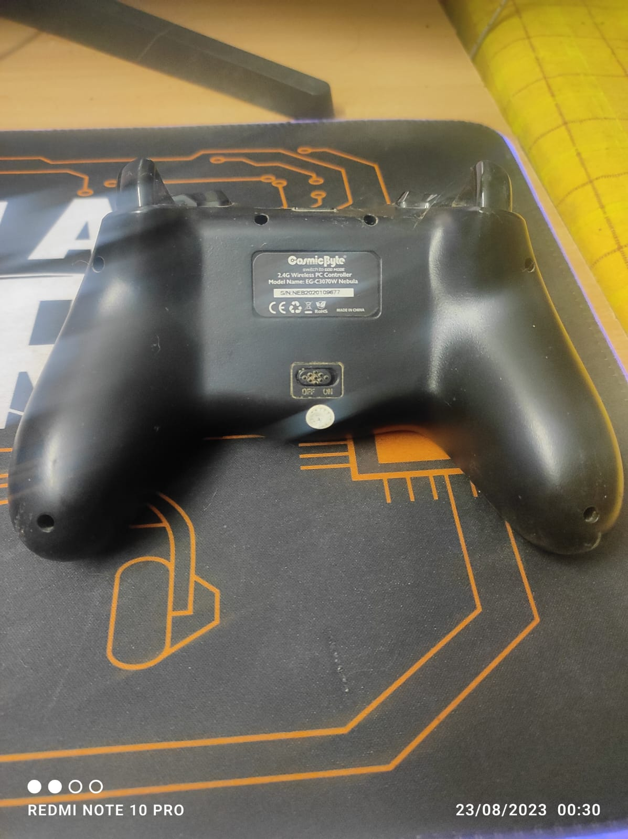

**Source –** My Room

**Constraints –** The small white seal is used to prevent the user from opening all the screws of the controller, so that the internal hardware won’t be changed, this helps the company tackle false hardware failure claims.

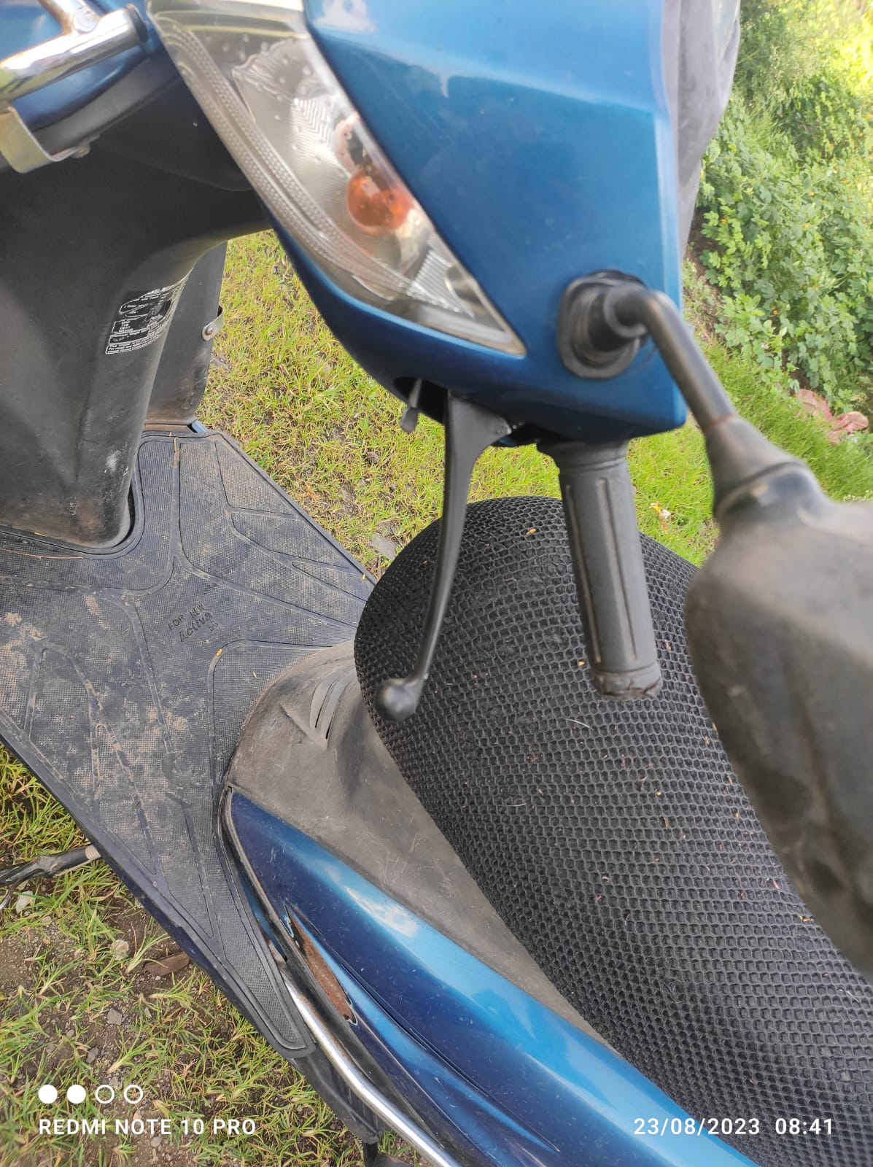

**Source –** My House (Parking)

**Constraints –** The Small Brake lock on left handle of Activa can be used to limit the bike speed.

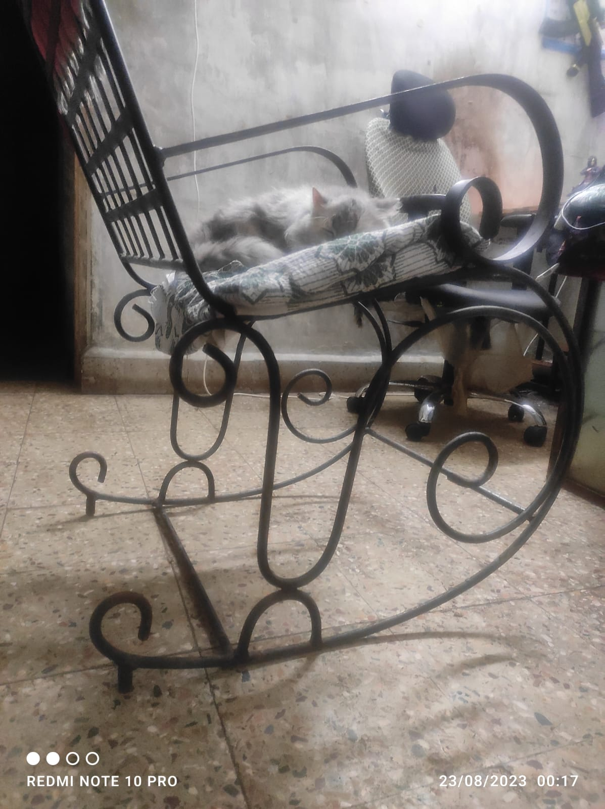

**Source –** My Room

**Constraints –** The Rocking chair has small bar stands at the end of the slide which prevents the chair from completely going backwards so that the person sitting on it won’t fall.

**Feedback – Sudarshan Patil**

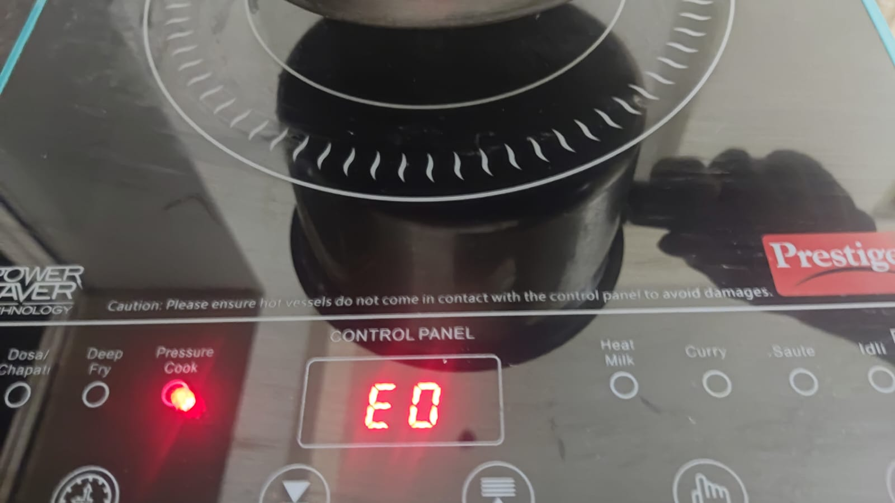

**Source –** My House (Kitchen)

**Feedback –** The Digital Indicator Indicates the level of the gas heating.

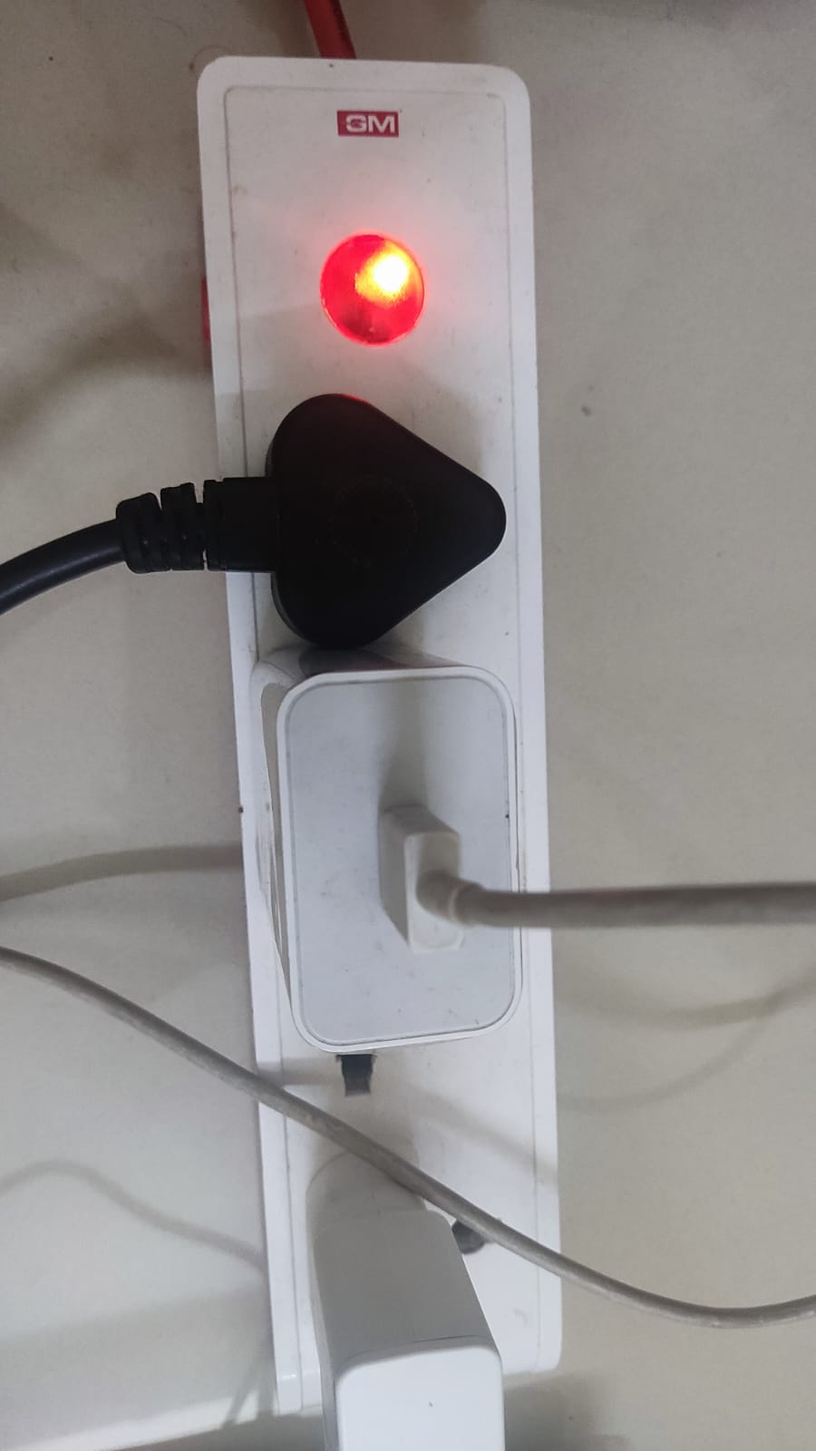

**Source –** My Room

**Feedback –** when the button of the extension is switched on the light on it indicates if its ON/OFF.

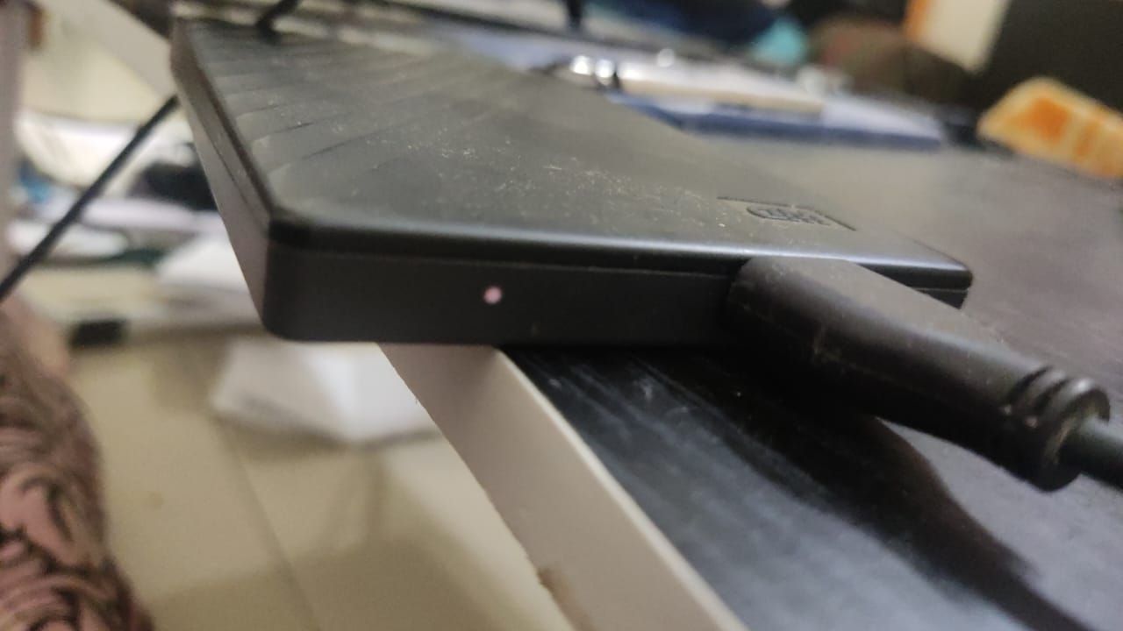

**Source –** My Room

**Feedback –** The small blinker on the hard disk indicates that the hard disk is connected.

**Constraints – Sudarshan Patil**

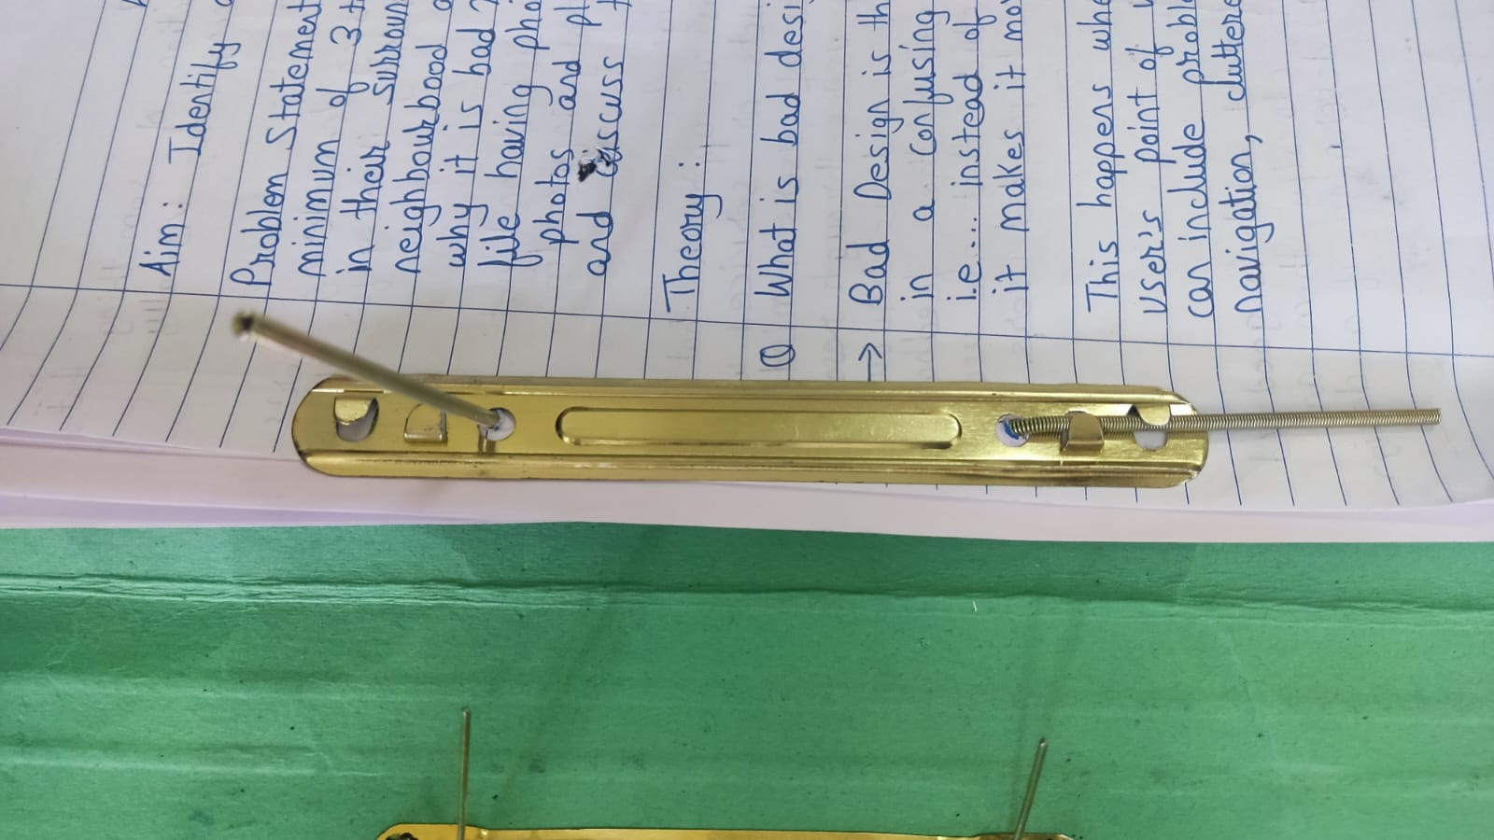

**Source –** My File (which I never complete)

**Constraints –** The metal strip prevents the pages from moving/scattering.

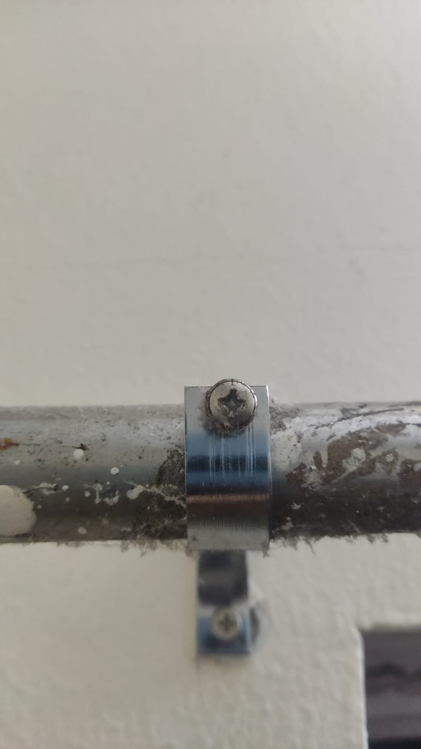

**Source –** My Room.

**Constraints –** The screw holds the pipe tightly so that it won’t move.

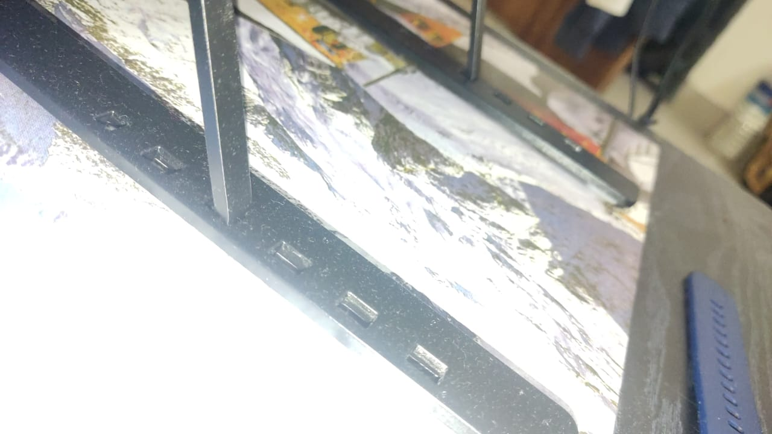

**Source –** My Laptop Desk

**Constraints –** These slots are used to adjust the laptop desk so that we can use it as per our comfort, the metal stick does not move after placing in the slots.